|  |  |  |
| --- | --- | --- |
| **Project Title *(English)*** | **Banking System** | |
| **Team** | Shiref Khaled  Mahitab Waleed  Karim Ashraf  Rawan Khaled  Amro momtaz | |
| **Field** | Computer Engineering | |
| **Program** | Artificial Intelligence Engineering | |
| **Instructor** | **Dr.Ibrahim Moauwd** | |
| **This part for instructor: Notice** | | **Degree** |
| **Date of Submission** |  | |

**Content**

**A. Abstract ...............................................................................................................**

**B. Introduction……………………………………………………**

**C. Objectives............................................................................................................**

**G. System Analysis and Design ...................................................................**

**H. Implementation and Outputs....................................................................**

**I. Conclusion............................................................................................................**

**Abstract project:** The Automatic Banking system gives user multiple operations to complete different tasks in a menu driven form.

Problem: During the Covid-19 pandemic the banks all over the world started to face difficulty to deal with the customers because of the social distancing and the precautionary measures taken by each country. Because of that the banks started to search for a solutions to work properly in the pandemic.

Solution: our group has created an Automatic banking system that can make the user make multiple operations without dealing with any human factor to stop the spread of covid-19, to solve the problem of social distancing in the bank and to make things easier for the user to finish faster and decreasing the human error.

**Introduction**: The automatic banking system allows the user to complete multiple operations including creating account, adding funds to an account, withdrawing funds from an account, deleting an account, editing user’s records and printing user’s information. The system works through a menu driven console application where the user is shown a menu with choices of multiple operations to complete their desired task.

# Objectives:

1. Allow the user to interact with an easy to follow interface.
2. Allow the user to create an account that stores their information in a database.
3. Let the user add funds to his/her account.
4. Let the user withdraw funds from his/her account.
5. Let the user to view his/her data.
6. Let the user change his/her password.
7. Let the user delete his/her account.

**System Analysis and Design:**

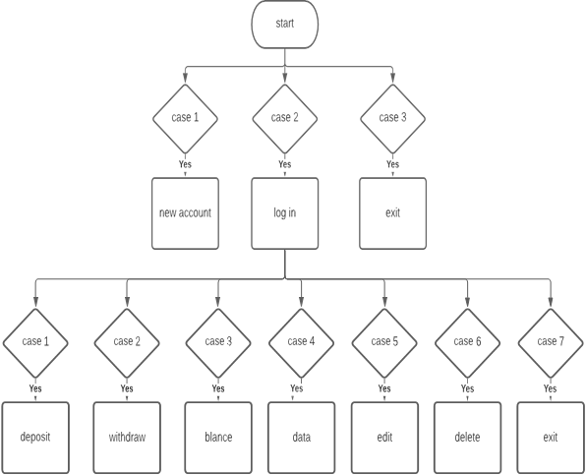

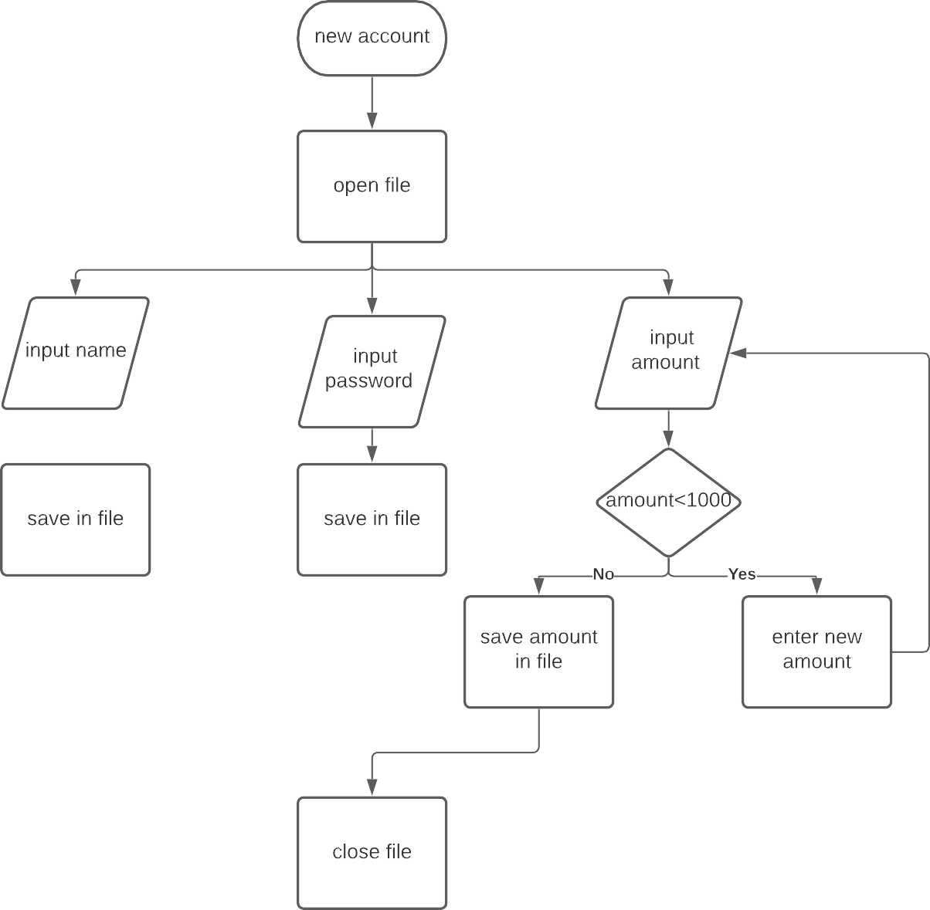

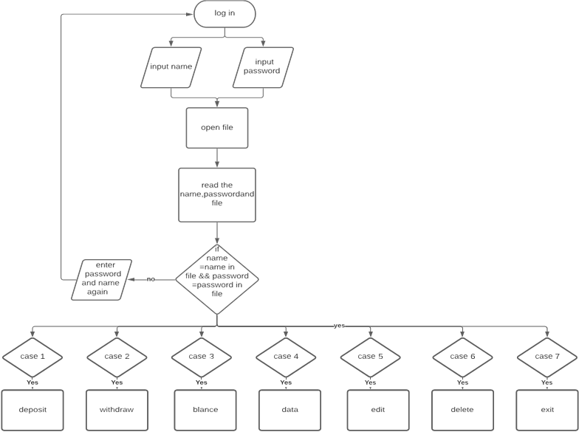

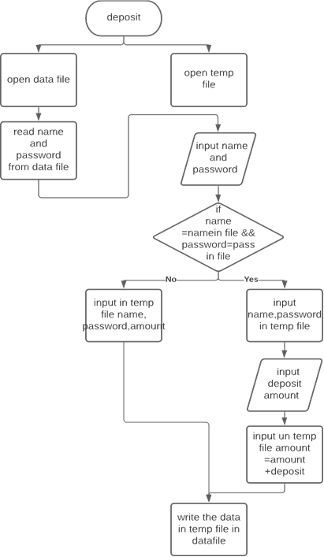

To search

From login

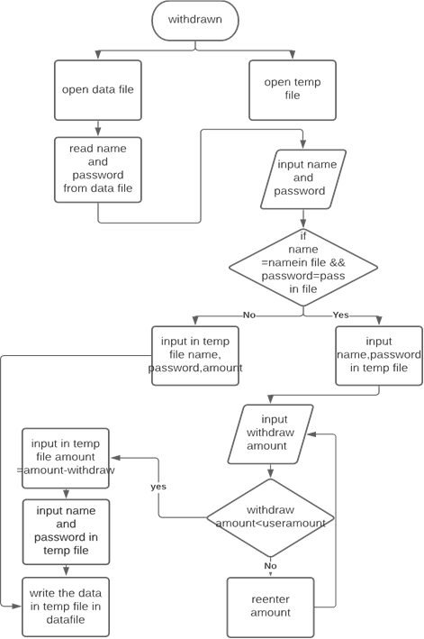

Close temp file

To search

From login

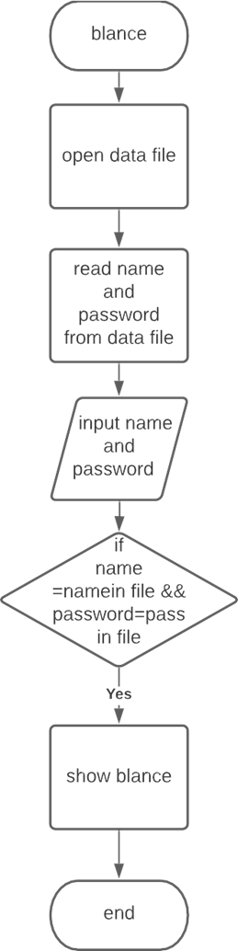

To search

From login

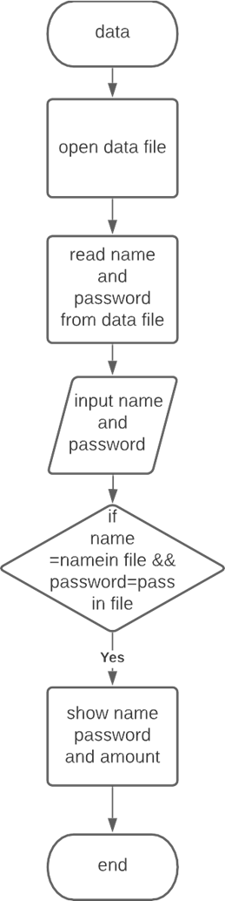

To search

From login

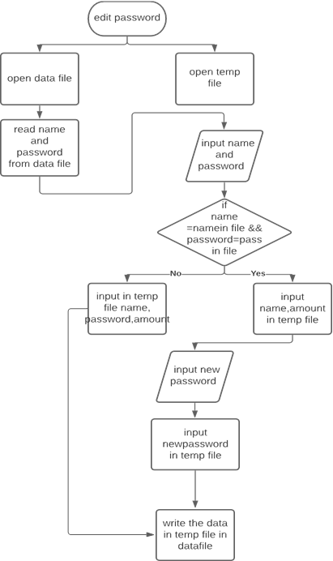

To search

From login

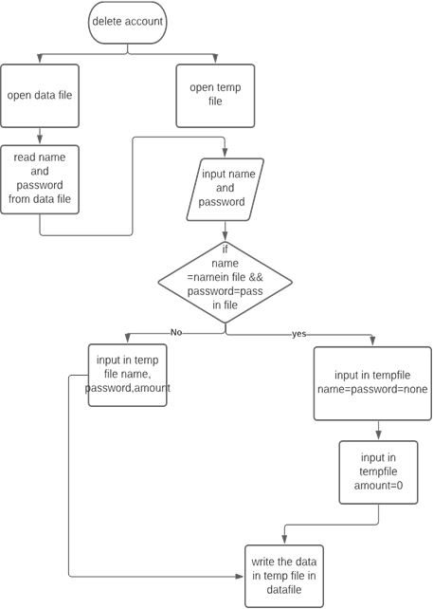

To search

From login

# Implementation and Outputs:

Full code:

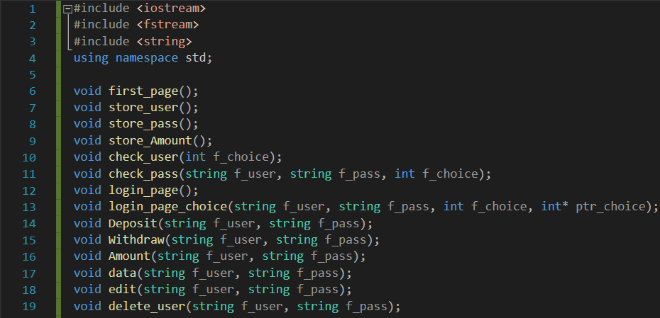

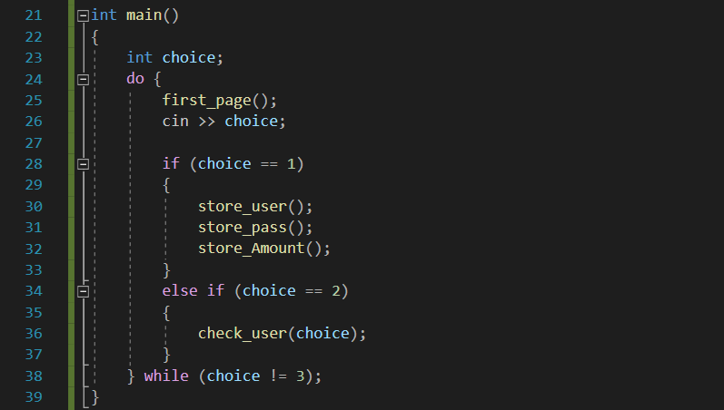

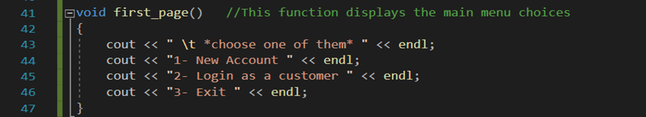

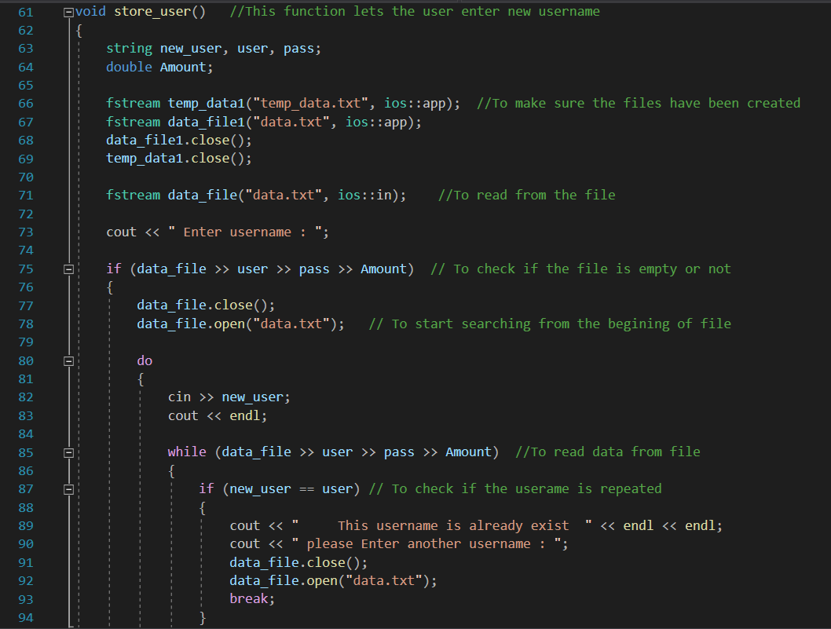

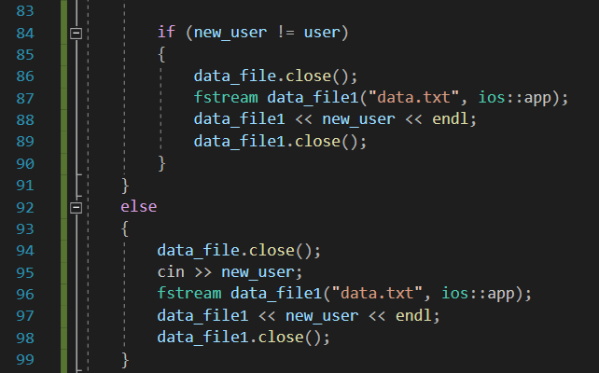

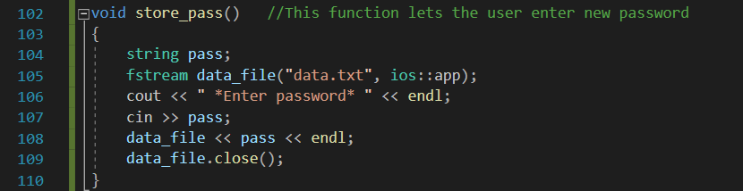

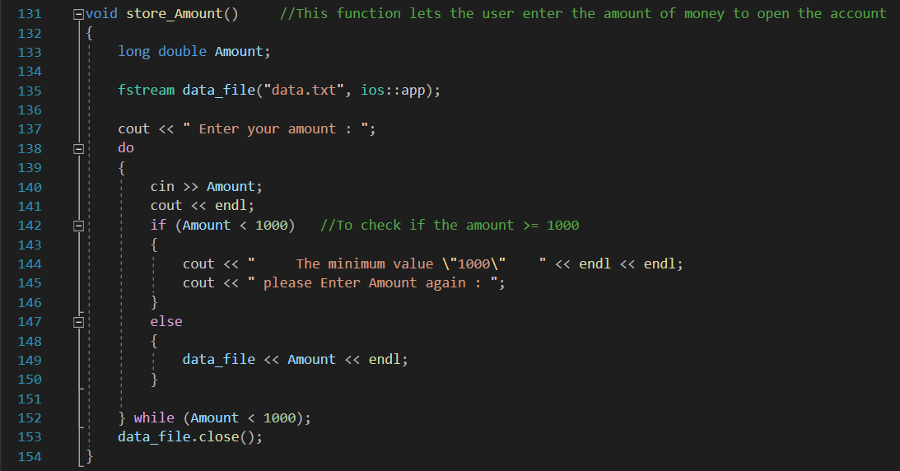

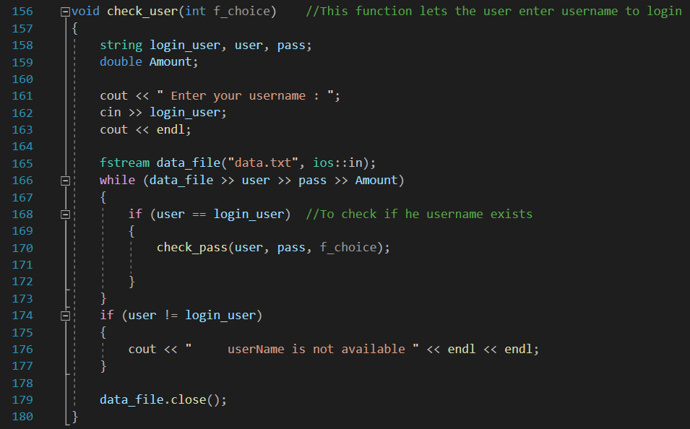

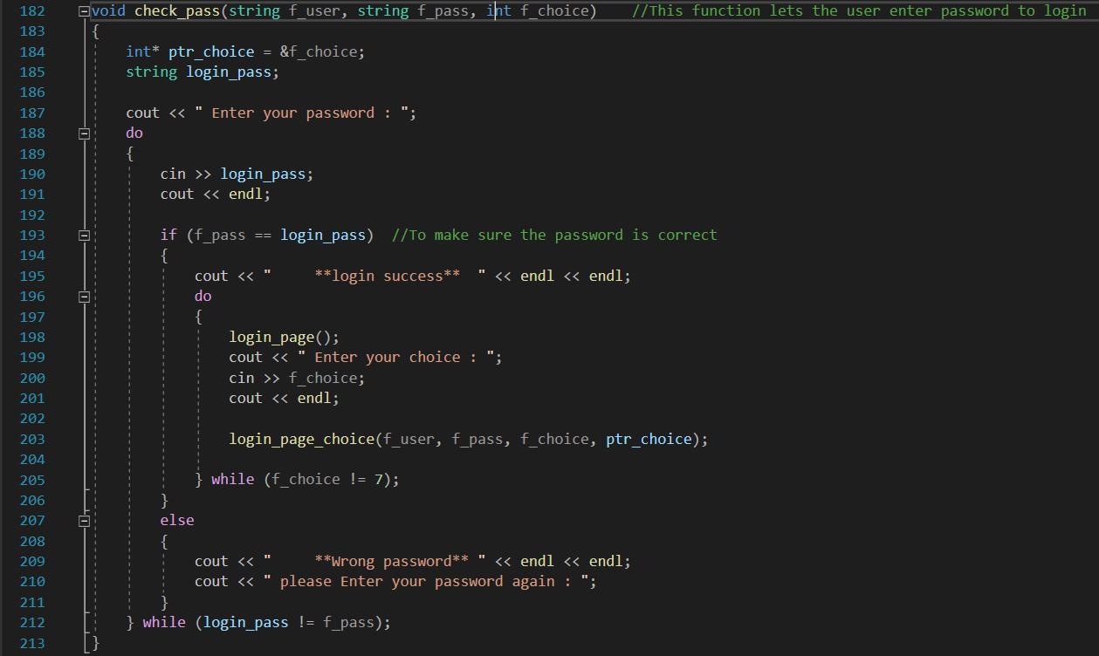

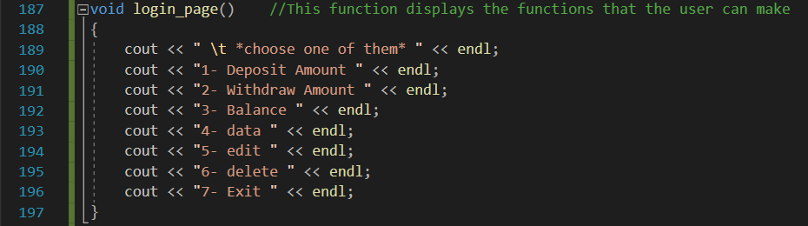

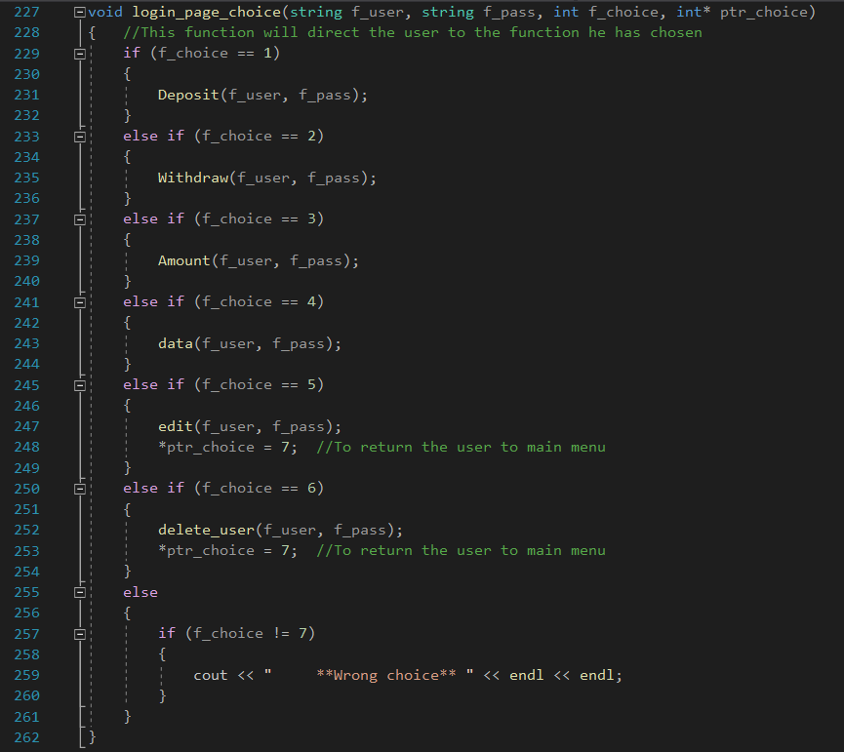

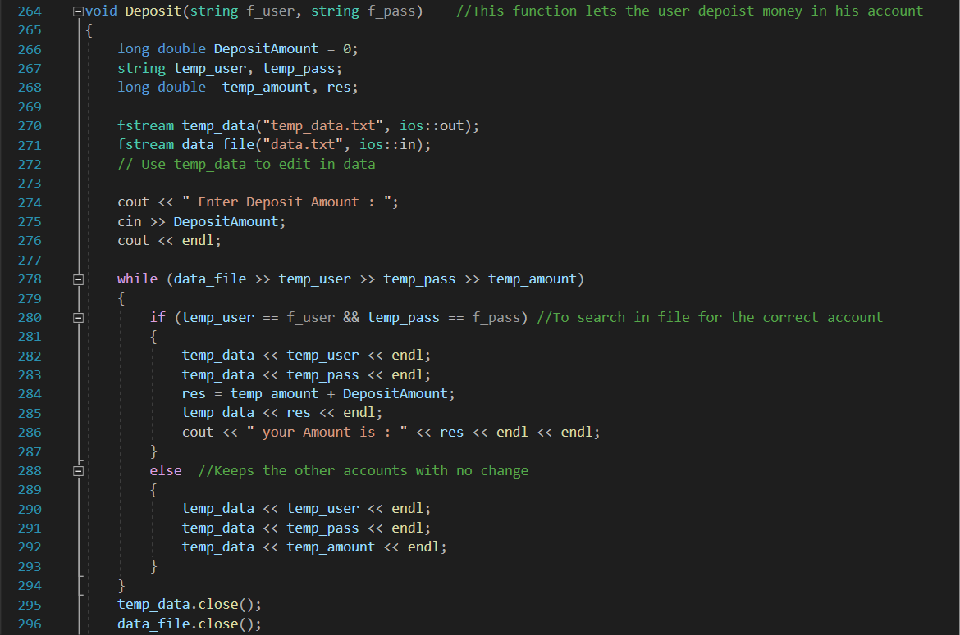

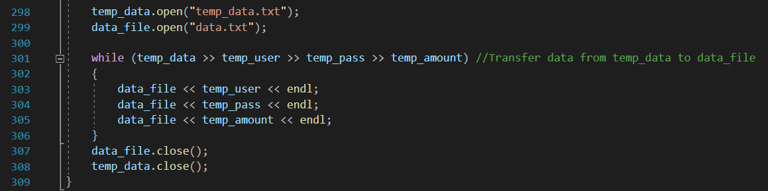

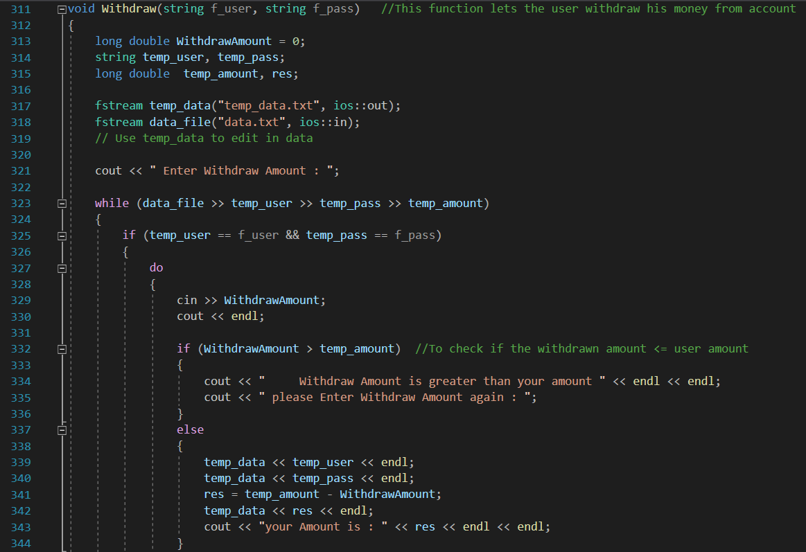

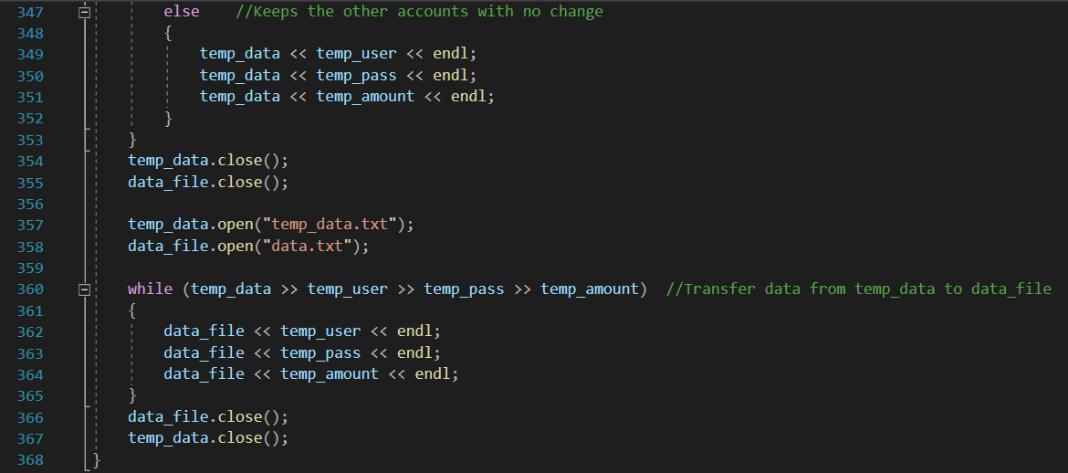

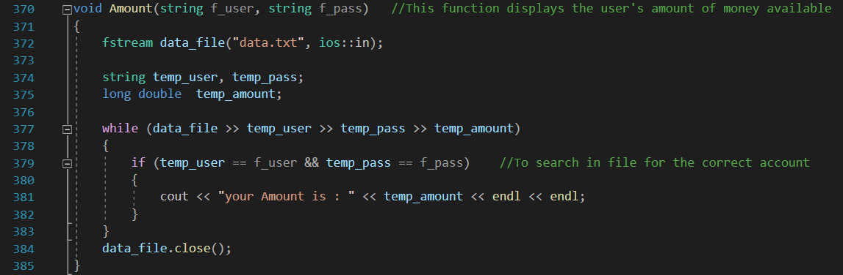

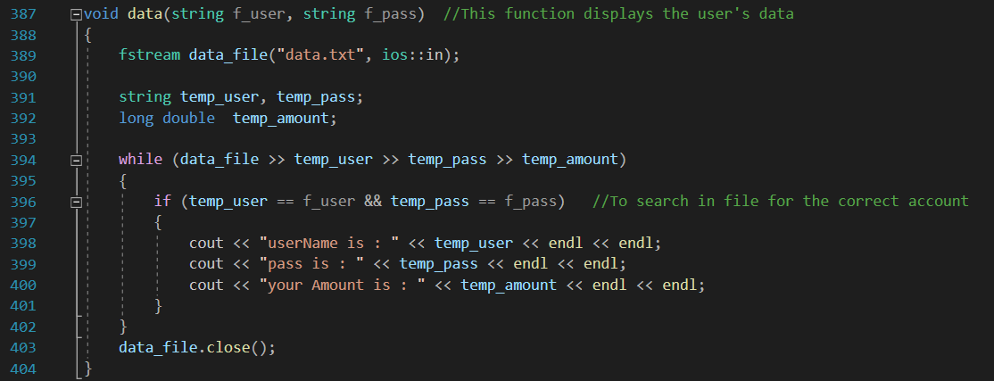

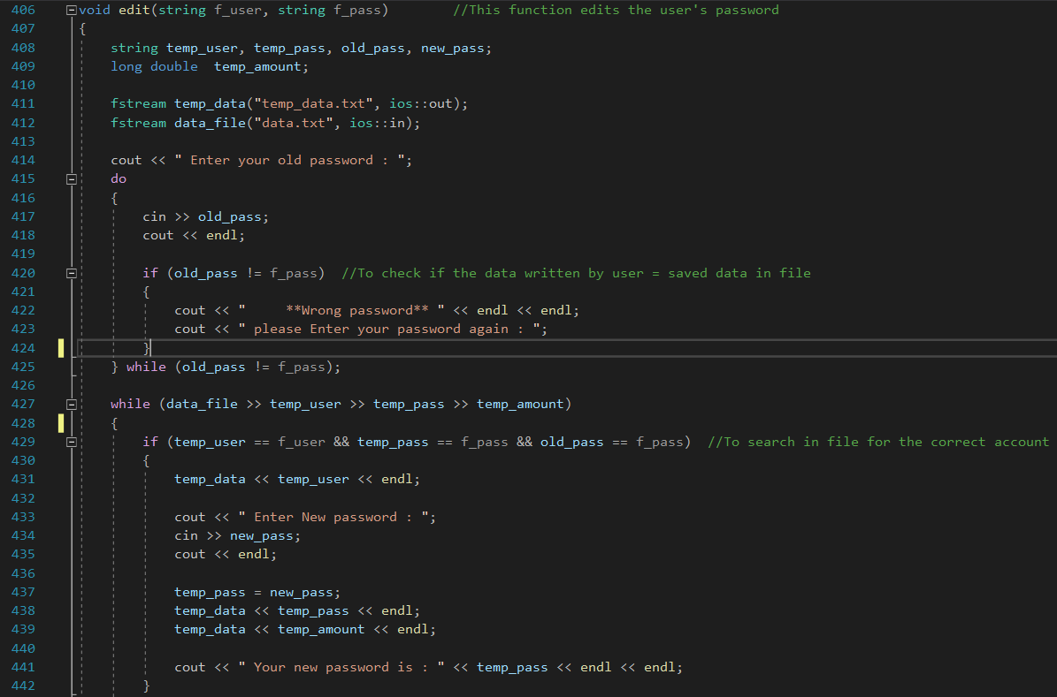

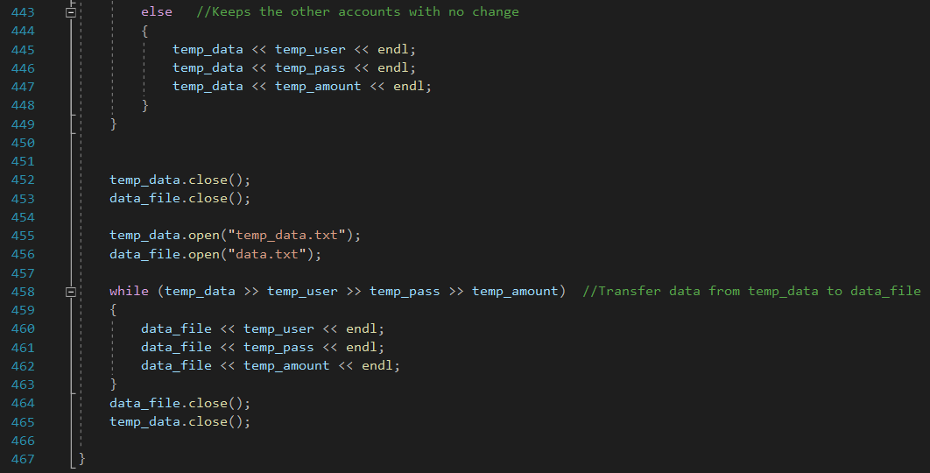

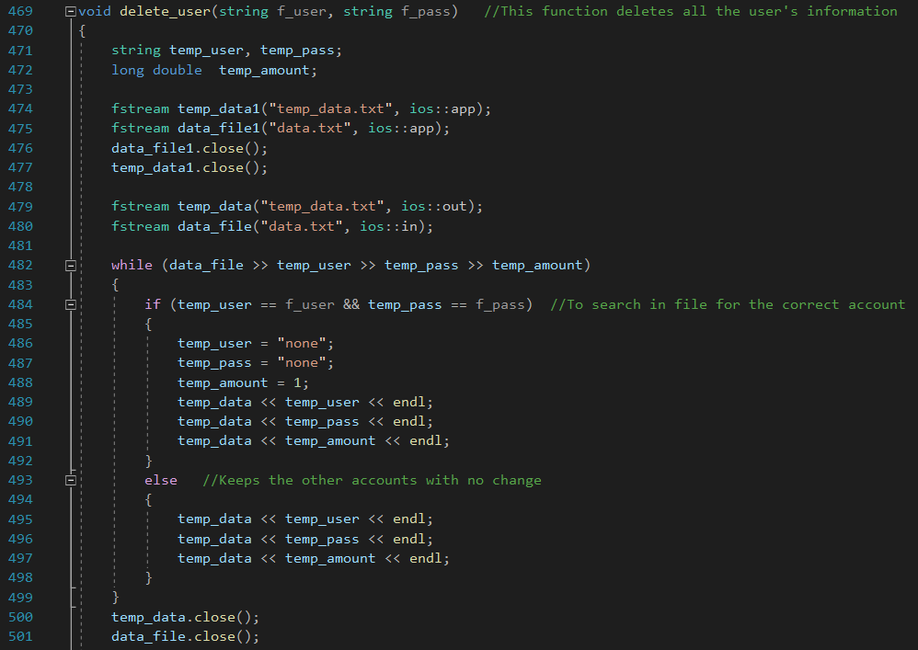

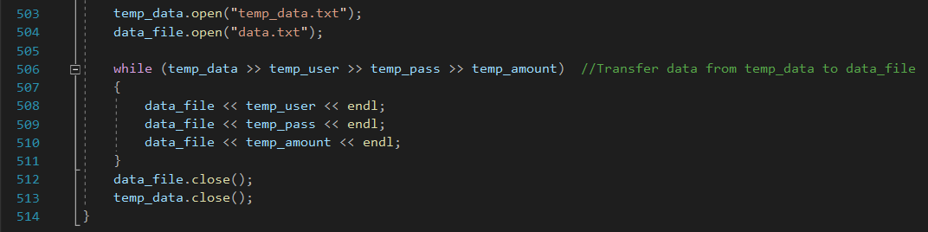

Test Data:

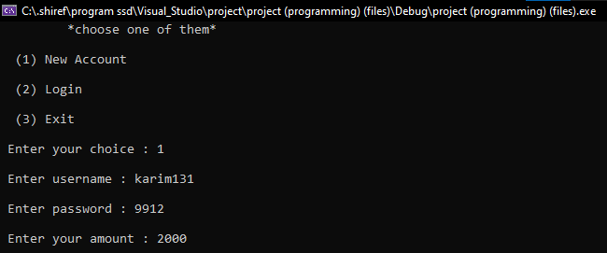

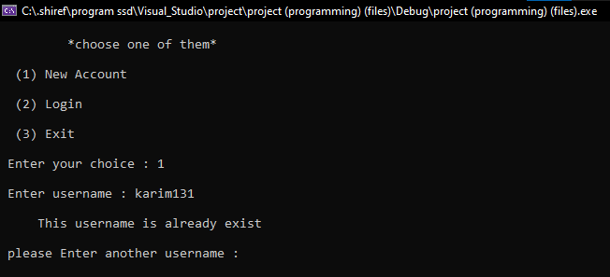

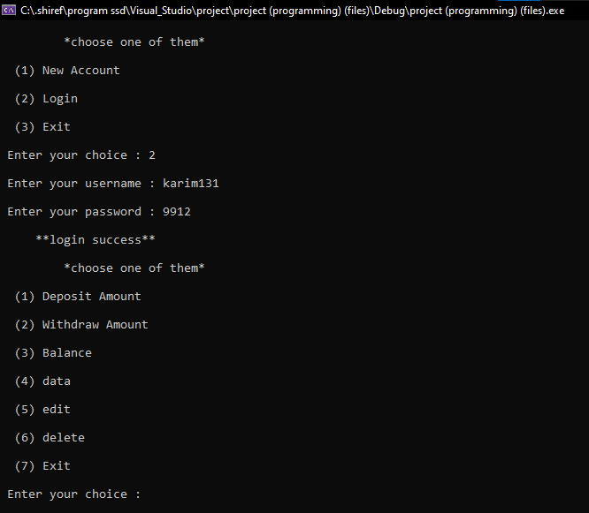

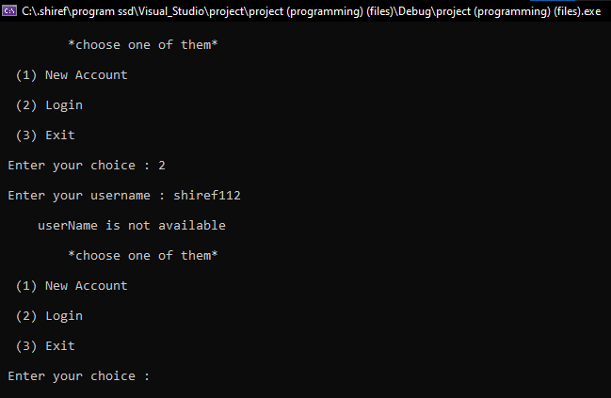

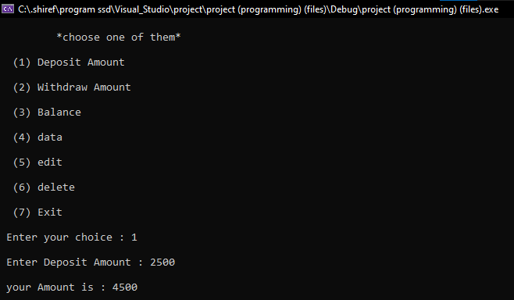

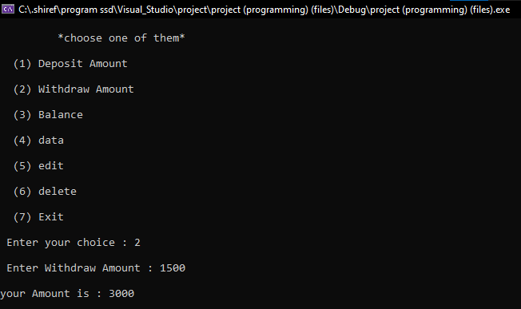

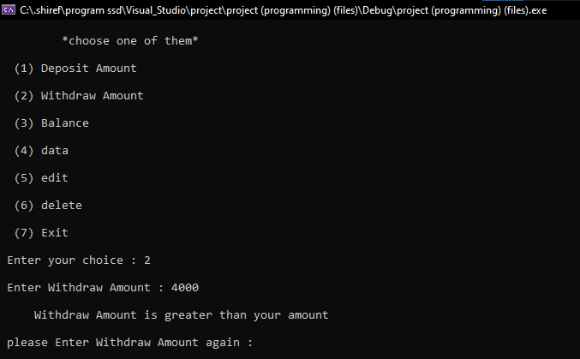

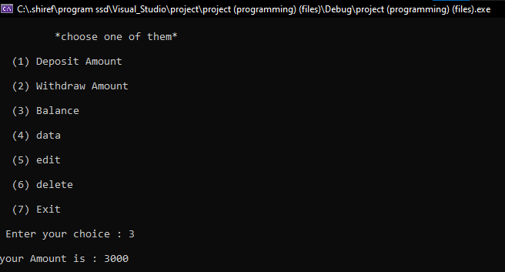

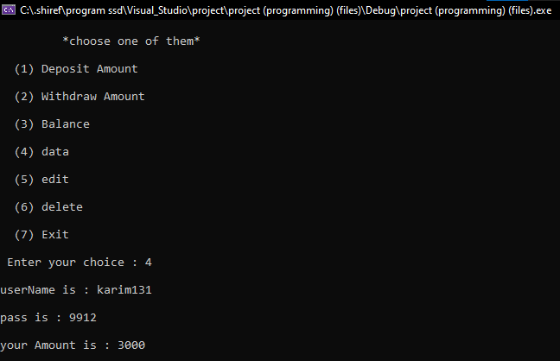

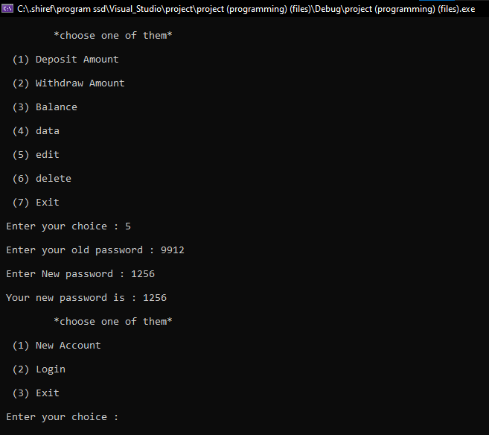

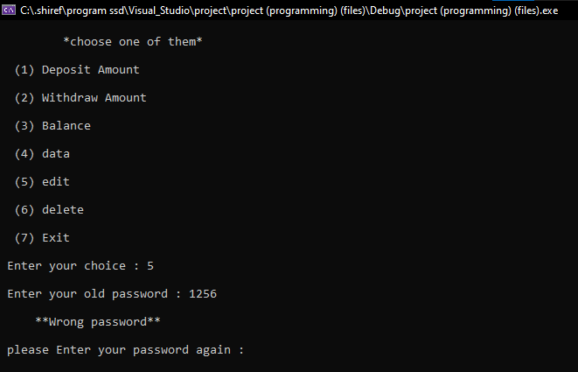

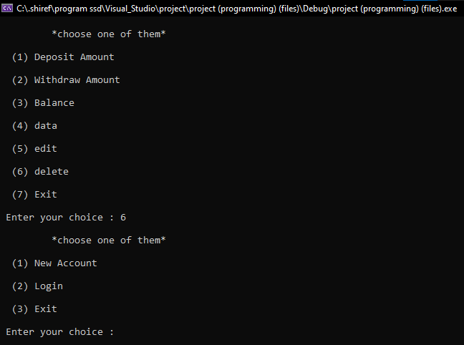

**Conclusion:** The automatic banking system is used to give the user multiple operations to choose from, as well as helping the users to meet their demands more efficiently instead of waiting in lines in front of the bank tellers to meet their demands and also to limit the dealing with human factors and limiting the spread of Covid-19.